==================================================

Running Genetic Algorithm with LightGBM...

==================================================

==================================================

=== GENETIC ALGORITHM OPTIMIZATION ===

==================================================

[Initialization]

- Population size: 30

- Generations: 20

- Crossover rate: 80%

- Mutation rate: 20%

- Search space: 50 features

- Target: Minimize MSE using LightGBM

==================================================

=== OPTIMIZATION RESULTS ===

==================================================

▶ Best MSE achieved: 0.143511

▶ Time elapsed: 459.37 seconds

▶ Features selected: 25/50 (50.0% reduction)

▶ Selected features:

1. CreditScore

2. AnnualIncome

3. LoanDuration

4. EmploymentStatus

5. EducationLevel

6. HomeOwnershipStatus

7. CreditCardUtilizationRate

8. BankruptcyHistory

9. LoanPurpose

10. PreviousLoanDefaults

11. InterestRate

12. PaymentHistory

13. EmergencyFundBalance

14. NetWorth

15. LengthOfCreditHistory

16. RentPayments

17. PersonalLoanBalance

18. LifeInsuranceStatus

19. CarInsuranceStatus

20. EmployerType

21. JobTenure

22. AnnualBonuses

23. AnnualExpenses

24. MonthlyHealthcareCosts

25. MonthlyEntertainmentCosts

▶ Convergence progress:

- Initial MSE: 0.1436

- Final MSE: 0.1435

- Improvement: 0.0%

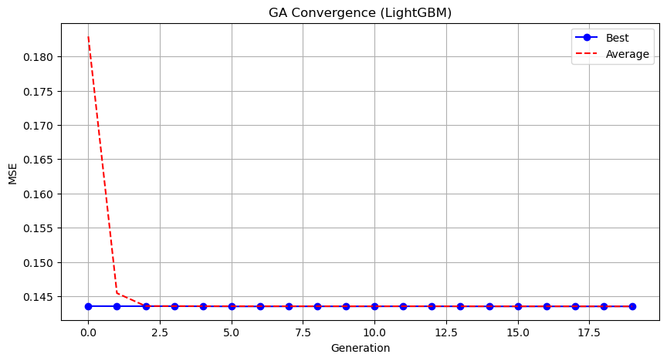

Genetic Algorithm completed successfully with MSE: 0.1435

==================================================

Running Particle Swarm Optimization with LightGBM...

==================================================

==================================================

=== PARTICLE SWARM OPTIMIZATION ===

==================================================

[Initialization]

- Swarm size: 30 particles

- Iterations: 20

- Cognitive weight: 0.5

- Social weight: 0.5

- Inertia weight: 0.5

- Search space: 50 features

- Target: Minimize MSE using LightGBM

==================================================

=== OPTIMIZATION RESULTS ===

==================================================

▶ Best MSE achieved: 0.143540

▶ Time elapsed: 77.32 seconds

▶ Features selected: 29/50 (42.0% reduction)

▶ Selected features (with weights):

1. CreditScore (weight: 0.766)

2. AnnualIncome (weight: 0.680)

3. LoanDuration (weight: 0.881)

4. Age (weight: 0.586)

5. EmploymentStatus (weight: 0.892)

6. MaritalStatus (weight: 0.624)

7. NumberOfDependents (weight: 0.503)

8. HomeOwnershipStatus (weight: 0.613)

9. CreditCardUtilizationRate (weight: 0.530)

10. NumberOfOpenCreditLines (weight: 0.785)

11. DebtToIncomeRatio (weight: 0.993)

12. LoanPurpose (weight: 0.953)

13. PreviousLoanDefaults (weight: 0.809)

14. PaymentHistory (weight: 0.919)

15. SavingsAccountBalance (weight: 0.807)

16. InvestmentAccountBalance (weight: 0.975)

17. EmergencyFundBalance (weight: 0.663)

18. TotalLiabilities (weight: 0.519)

19. LengthOfCreditHistory (weight: 0.501)

20. RentPayments (weight: 0.866)

21. AutoLoanBalance (weight: 0.676)

22. UtilityBillsPaymentHistory (weight: 0.999)

23. HealthInsuranceStatus (weight: 0.719)

24. JobTenure (weight: 0.667)

25. MonthlySavings (weight: 0.673)

26. AnnualBonuses (weight: 0.889)

27. MonthlyHousingCosts (weight: 0.543)

28. MonthlyHealthcareCosts (weight: 0.805)

29. MonthlyEntertainmentCosts (weight: 0.676)

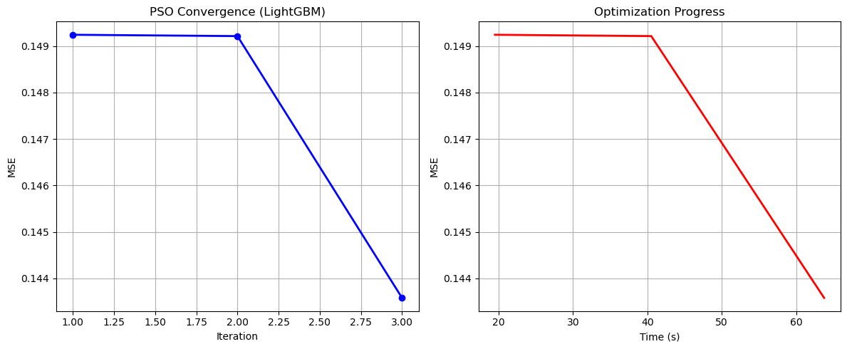

Particle Swarm Optimization completed successfully with MSE: 0.1435

==================================================

Running Whale Optimization with LightGBM...

==================================================

==================================================

=== WHALE OPTIMIZATION ALGORITHM ===

==================================================

[Initialization]

- Population: 30 whales

- Max iterations: 20

- Spiral coefficient (b): 1.0

- Search space: 50 features

- Target: Minimize MSE using LightGBM

==================================================

=== OPTIMIZATION RESULTS ===

==================================================

▶ Best MSE achieved: 0.143545

▶ Time elapsed: 573.24 seconds

▶ Features selected: 38/50 (24.0% reduction)

▶ Selected features:

1. CreditScore

2. AnnualIncome

3. LoanAmount

4. Age

5. EmploymentStatus

6. MaritalStatus

7. NumberOfDependents

8. EducationLevel

9. HomeOwnershipStatus

10. MonthlyDebtPayments

11. CreditCardUtilizationRate

12. NumberOfOpenCreditLines

13. NumberOfCreditInquiries

14. BankruptcyHistory

15. LoanPurpose

16. PreviousLoanDefaults

17. PaymentHistory

18. SavingsAccountBalance

19. CheckingAccountBalance

20. InvestmentAccountBalance

21. RetirementAccountBalance

22. EmergencyFundBalance

23. TotalLiabilities

24. MortgageBalance

25. RentPayments

26. PersonalLoanBalance

27. StudentLoanBalance

28. HealthInsuranceStatus

29. LifeInsuranceStatus

30. CarInsuranceStatus

31. OtherInsurancePolicies

32. EmployerType

33. JobTenure

34. MonthlySavings

35. AnnualExpenses

36. MonthlyTransportationCosts

37. MonthlyHealthcareCosts

38. MonthlyEntertainmentCosts

▶ Convergence progress:

- Initial MSE: 0.2500

- Final MSE: 0.1435

- Improvement: 42.6%

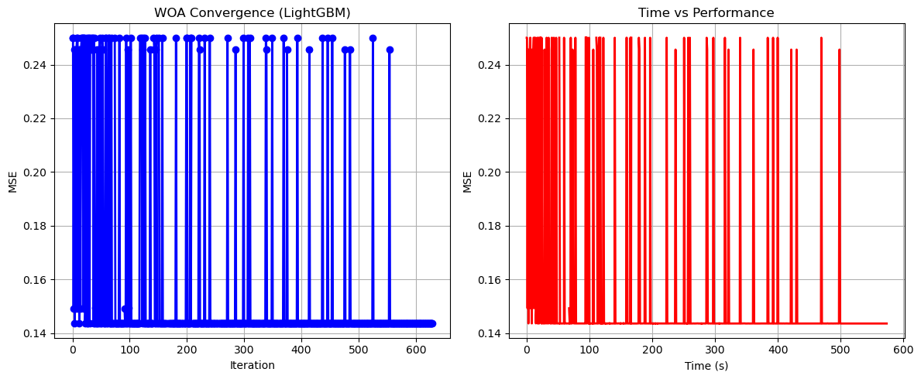

Whale Optimization completed successfully with MSE: 0.1435

==================================================

Running Squid Game Optimizer with LightGBM...

==================================================

==================================================

=== SQUID GAME OPTIMIZER (SGO) ===

==================================================

[Initialization]

- Players: 30 (15 offensive, 15 defensive)

- Max games: 20

- Search space: 50 features

- Target: Minimize MSE using LightGBM

==================================================

=== OPTIMIZATION RESULTS ===

==================================================

▶ Best MSE achieved: 0.143534

▶ Time elapsed: 488.99 seconds

▶ Features selected: 27/50 (46.0% reduction)

▶ Selected features:

1. CreditScore

2. AnnualIncome

3. LoanDuration

4. Age

5. EmploymentStatus

6. MaritalStatus

7. NumberOfDependents

8. HomeOwnershipStatus

9. MonthlyDebtPayments

10. CreditCardUtilizationRate

11. NumberOfOpenCreditLines

12. NumberOfCreditInquiries

13. DebtToIncomeRatio

14. LoanPurpose

15. PaymentHistory

16. SavingsAccountBalance

17. TotalAssets

18. TotalLiabilities

19. NetWorth

20. LengthOfCreditHistory

21. AutoLoanBalance

22. StudentLoanBalance

23. HomeInsuranceStatus

24. EmployerType

25. MonthlySavings

26. AnnualBonuses

27. MonthlyFoodCosts

▶ Convergence progress:

- Initial MSE: 0.1436

- Final MSE: 0.1435

- Improvement: 0.0%

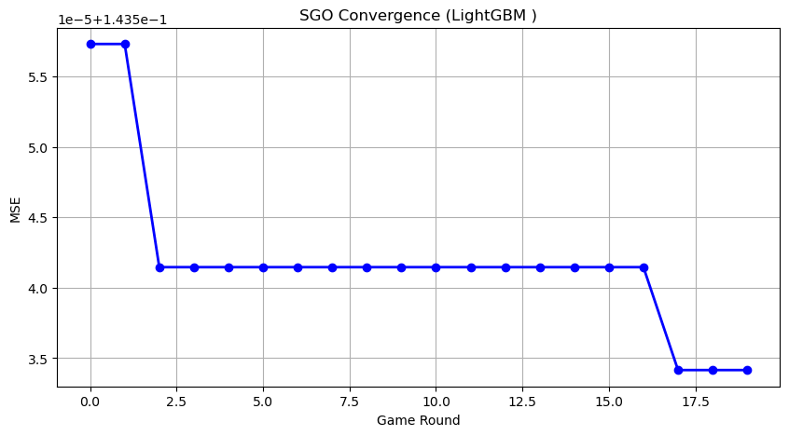

Squid Game Optimizer completed successfully with MSE: 0.1435

==================================================

Running PSH-Hyptrite with LightGBM...

==================================================

==================================================

=== PSH-HYPTRITE OPTIMIZATION ===

==================================================

[Initialization]

- Search points: 30

- Max iterations: 20

- Initial radius: 0.5 (adaptive)

- Hypersphere samples: 3 per point

- Search space: 50 features

- Target: Minimize MSE using LightGBM

Training until validation scores don't improve for 10 rounds

Early stopping, best iteration is:

==================================================

=== OPTIMIZATION RESULTS ===

==================================================

▶ Best MSE achieved: 0.143515

▶ Time elapsed: 1551.77 seconds

▶ Features selected: 28/50 (44.0% reduction)

▶ Selected features (with weights):

1. CreditScore (weight: 0.638)

2. AnnualIncome (weight: 0.533)

3. LoanAmount (weight: 0.547)

4. Age (weight: 0.643)

5. EmploymentStatus (weight: 0.836)

6. NumberOfDependents (weight: 0.967)

7. EducationLevel (weight: 0.509)

8. HomeOwnershipStatus (weight: 0.797)

9. NumberOfCreditInquiries (weight: 0.504)

10. CheckingAccountBalance (weight: 0.891)

11. InvestmentAccountBalance (weight: 0.758)

12. EmergencyFundBalance (weight: 0.943)

13. TotalLiabilities (weight: 0.997)

14. LengthOfCreditHistory (weight: 0.858)

15. AutoLoanBalance (weight: 0.605)

16. StudentLoanBalance (weight: 0.674)

17. HealthInsuranceStatus (weight: 0.545)

18. LifeInsuranceStatus (weight: 0.869)

19. CarInsuranceStatus (weight: 0.599)

20. HomeInsuranceStatus (weight: 0.546)

21. OtherInsurancePolicies (weight: 0.907)

22. JobTenure (weight: 0.792)

23. MonthlySavings (weight: 0.675)

24. AnnualBonuses (weight: 0.674)

25. AnnualExpenses (weight: 0.709)

26. MonthlyFoodCosts (weight: 0.594)

27. MonthlyHealthcareCosts (weight: 0.964)

28. MonthlyEntertainmentCosts (weight: 0.737)

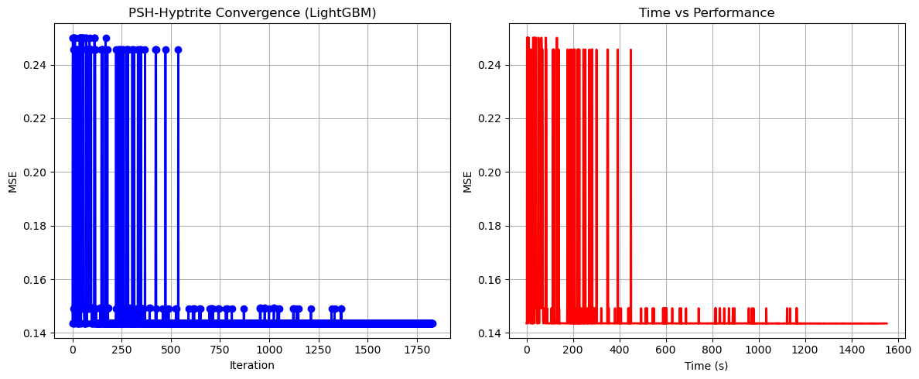

PSH-Hyptrite completed successfully with MSE: 0.1435

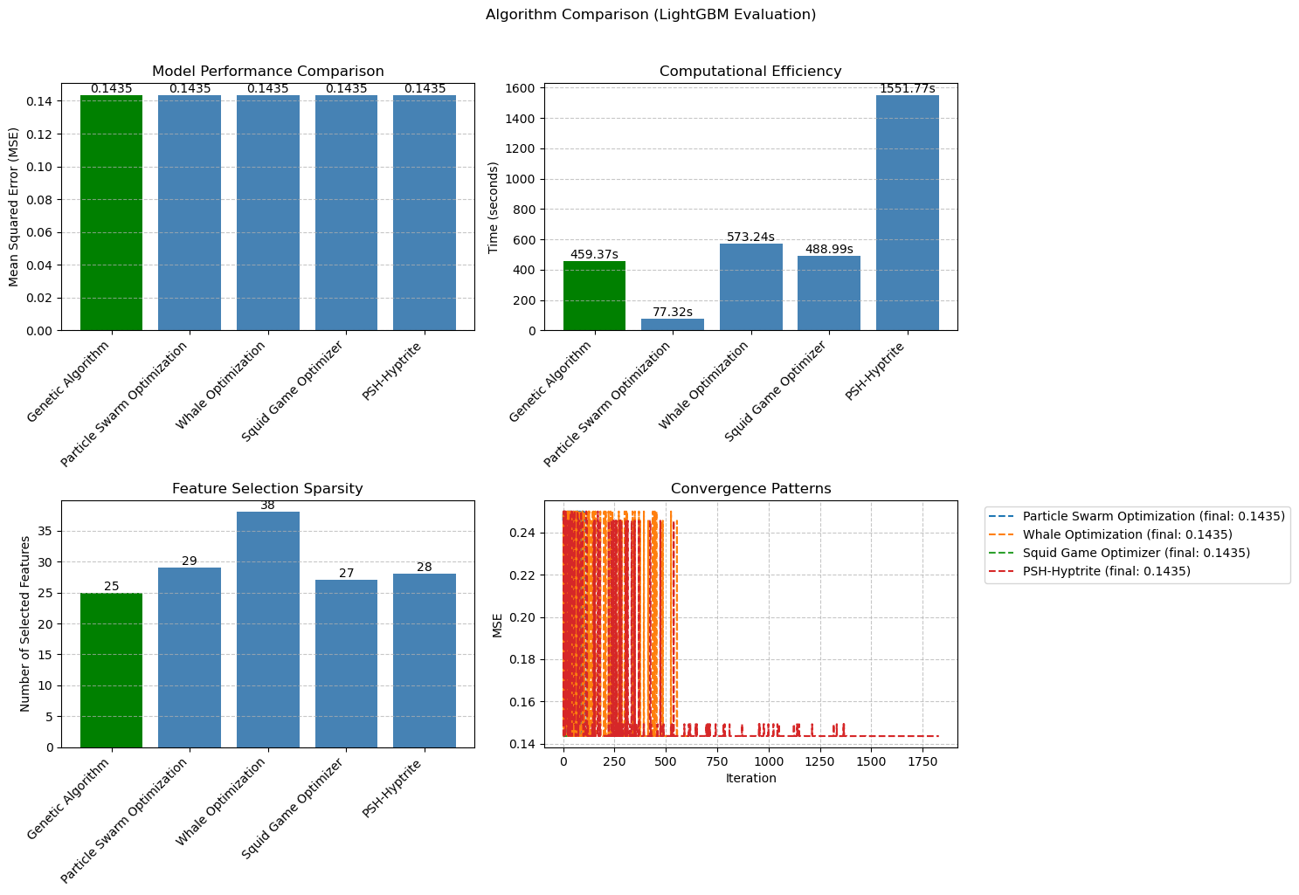

============================================================

=== FINAL FEATURE SELECTION RESULTS USING LightGBM ===

============================================================

🏆 BEST ALGORITHM: GENETIC ALGORITHM

• MSE: 0.143511

• Time: 459.37 seconds

• Features: 25/50 (50.0% reduction)

📊 COMPARISON TABLE:

Algorithm MSE Time (s) Features

---------------------------------------------------------------------------

Genetic Algorithm 0.143511 459.37 25

PSH-Hyptrite 0.143515 1551.77 28

Squid Game Optimizer 0.143534 488.99 27

Particle Swarm Optimization 0.143540 77.32 29

Whale Optimization 0.143545 573.24 38

🔍 SELECTED FEATURES:

1. CreditScore

2. AnnualIncome

3. LoanDuration

4. EmploymentStatus

5. EducationLevel

6. HomeOwnershipStatus

7. CreditCardUtilizationRate

8. BankruptcyHistory

9. LoanPurpose

10. PreviousLoanDefaults

11. InterestRate

12. PaymentHistory

13. EmergencyFundBalance

14. NetWorth

15. LengthOfCreditHistory

16. RentPayments

17. PersonalLoanBalance

18. LifeInsuranceStatus

19. CarInsuranceStatus

20. EmployerType

21. JobTenure

22. AnnualBonuses

23. AnnualExpenses

24. MonthlyHealthcareCosts

25. MonthlyEntertainmentCosts

💡 Tip: Consider feature importance from LightGBM for further analysis